Experiment 5

DETERMINATION OF MOMENT OF INERTIA BASED ON TORSIONAL VIBRATION

Instruments: 1. Torsion apparatus;
2. Torsion rods (steel)
3. Spring balance;
4. Stop watch;
5. Sliding weight
6. Support rods and base.

Purpose of the experiment: Bars of various materials will be exciting into torsion vibration. The relationship between the torsion and the deflection as well as the torsion period and moment of inertia will be derived. As a result, moment of inertia of a long bar can be determined.

I. THEORETICAL BACKGROUND

If a body is regarded as a continuum, and if 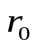and 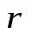denote the position vector of a point p in the undeformed and deformed states of the body, then for small displacement vectors:
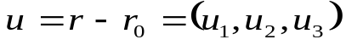 (1)
and the deformation tensor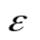is: 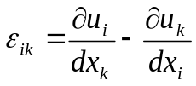
The forces 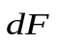which act on a volume element of the body, the edges of the element being cut parallel to the coordinate planes, are described by the stress tensor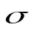:
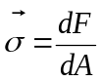 (2)
Hooke’s law provides the relationship betweenand:  = E. , where E is elastic modulus.
For a bar subjected to a torque as shown in Fig.1, the angular restoring torque or torsion modulus D_{τ} can be determined by:  τ_{z} = D_{τ.}.φ (3)  From Newton’s basic equation for rotary motion, we have:  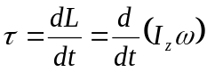 (4)  Combination eq. 3 and 4 we obtain the equation of vibration as follows:  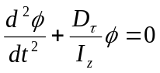 (5)  The period of this vibration is:  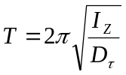 (6) | 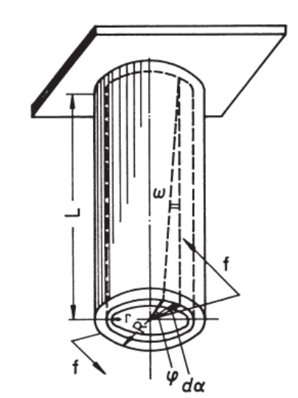  Fig.1: Torsion in a bar

The linear relationship between τ_{z} and φ shown in Fig. 2 allows to determine D_{τ.} and consequently the moment of inertia of the long rod.

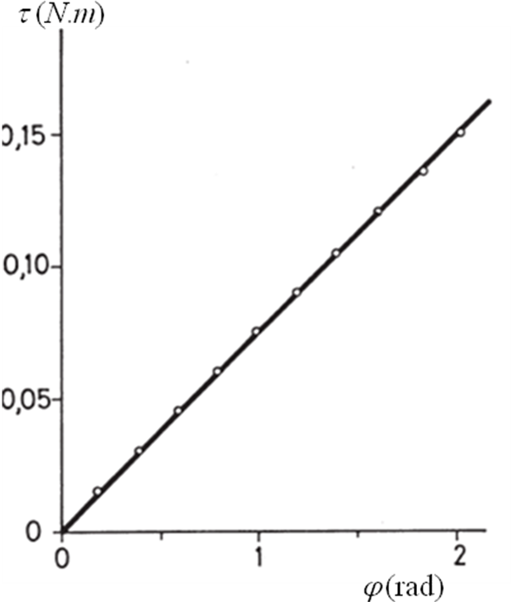

Fig.2: Torque and deflection of a torsion bar

II. EXPERIMENTAL PROCEDURE

1. Set-up experiment

The experimental set-up is arranged as shown in Fig. 3.  - For the static determination of the torsion modulus, the spring balance acts on the beam at r = 0.15 cm. The spring balance and lever arm form a right angle.  - It is recommended that the steel bar, 0.5 m long, 0.002 m dia., is used for this experiment, since it is distinguished by a wide elastic range. The steel bar is also preferable for determining the moment of inertia of the rod with the two masses arranged symmetrically  2. How to perform the experiment  - Step 1: Assemble the steel rod on the torsion apparatus.  - Step 2: Use the spring balance of force to turn the disk being deflected an angle ϕ.  - Step 3: Record the value of force F shown on the spring balance and the distance of the lever arm. | 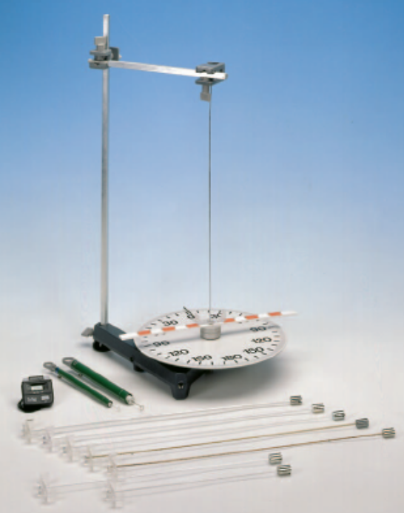  Fig.3: Experimental set-up

- Step 4: Pull out to turn the disk being deflected an angle ϕ, then let it vibration and use the stopwatch to determine the vibration period.

III. PROCESSING OF EXPERIMENTAL DATA

1. Make a graph showing the relationship of torsion on deflection angle ϕ.
2. Determination of the torsion modulus D_{τ}.
3. Calculation of the moment of inertia of the long rod using the eq. (6).

